**Experiment no – 01 (B)**

**Aim:** Write the program for the following: (by using control statements and control structure)

(B). Enter the number from the user and depending on whether the number is even or odd, print out an appropriate message to the user.

**Theory: -**

**Practical Implementation**:-

**Code**:-

#Enter the number from the user and depending on whether the number is even or odd, print out an appropriate message to the user.

# Python program to check if the input number is odd or even.

# A number is even if division by 2 give a remainder of 0.

# If remainder is 1, it is odd number.

num = int(input("Enter a number: "))

if (num % 2) == 0:

print("{0} is Even".format(num))

else: print("{0} is Odd".format(num))

**Output:**

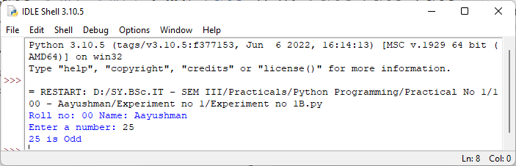

**Conclusion:** Successfully performed and Implemented the Program.